

**Department of Electrical and Computer Engineering**

| Course Number | CPS510 |
| --- | --- |
| Course Title | Database Systems I |
| Semester/Year | F2022 |
| Instructor | Dr. S. B. Tajali |
| Lab Section | 7 |

| Assignment No. | 6 |
| --- | --- |
| Assignment Title | Assignment 6: Normalization of the database/ Functional Dependencies |

| Submission Date: | October 31, 2022 |
| --- | --- |
| Due Date: | October 31, 2022 |

| Student Name | Ethan Moo-Young | Ernestine Ho | Abel Abraham Thomas |
| --- | --- | --- | --- |
| Student ID | 501016708 | 501022253 | 501029194 |
| Signature |  |  |  |

Contents of [Book] Table

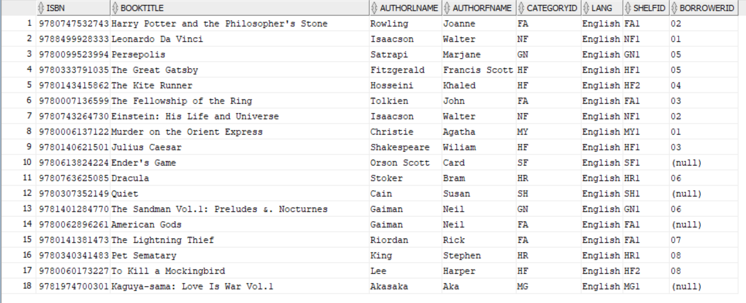

The [Book] table does not satisfy the requirements of 3NF or BCNF. In this table, ISBN is the primary key. BorrowerId does not relate to the ISBN of a book at all, so it should be removed from the table. ShelfId depends on CategoryId which depends on ISBN, this makes ShelfId a partial dependency.

To fix the [Book] table, we will make another table called BorrowedBooks for borrowed books which will include columns such as BorrowerId and IssuedBy.

Book(ISBN, BookTitle, AuthorLname, AuthorFname, CategoryId, Lang, ShelfId, BorrowerId)

Contents of [Category] Table

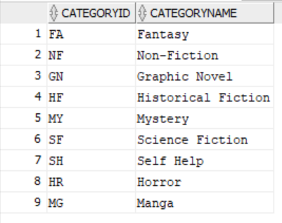

The [Category] Table is a very simple table that satisfies 1NF, which in turn satisfies 2NF and 3NF.

Category(CategoryId, CategoryName)

Contents of [Client] Table

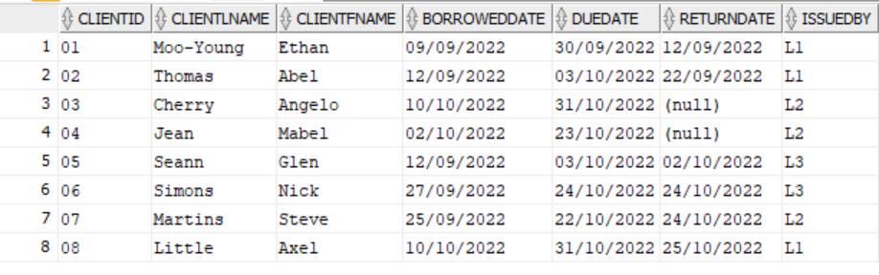

The [Client] Table does not satisfy the requirements of 3NF or BCNF. The primary key of this table is ClientId. BorrowedDate, DueDate, ReturnDate, and IssuedBy do not relate to the primary key of this table and will be moved to another table called BorrowedBooks.

Client(ClientId, ClientLname, ClientFname, BorrowedDate, DueDate, ReturnDate, IssuedBy)

Contents of [Shelf] Table

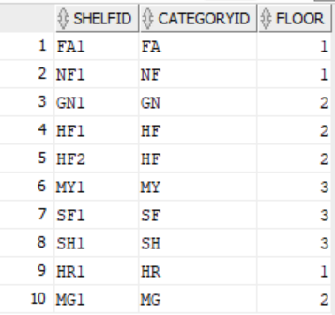

The [Shelf] Table is alright. The ShelfId column will be rewritten to relate to CategoryId and Floor.

I.e: HF2, HF, 2

Shelf(ShelfId, CategoryId, Floor)

Contents of [Staff] Table

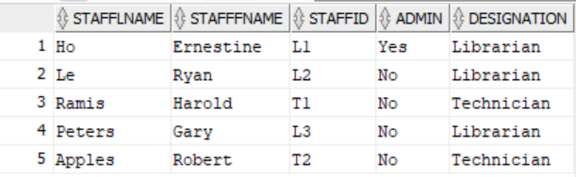

The [Staff] Table satisfies the requirements of 3NF. All non-key attributes are non-transitively dependent on the primary key.

Staff(StaffLname, StaffFname, StaffId, Admin, Designation)